1. Provide the list of markets in which customer "Atliq Exclusive" operates its business in the APAC region.

SELECT market FROM

gdb023.dim_customer

where customer='Atliq Exclusive' and region='APAC';

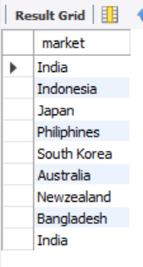

1. What is the percentage of unique product increase in 2021 vs. 2020? The final output contains these fields,

unique_products_2020

unique_products_2021

percentage_chg

with unique_products as(

Select

count(distinct case when fiscal_year=2020 then product_code end) as unique_products_2020,

count(distinct case when fiscal_year=2021 then product_code end) as unique_products_2021

from fact_sales_monthly)

select *,

ROUND((unique_products_2021-unique_products_2020)*100 / unique_products_2020,2) as per_diff

from unique_products;

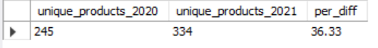

1. Provide a report with all the unique product counts for each segment and sort them in descending order of product counts. The final output contains 2 fields,

segment product_count

SELECT segment, COUNT(Distinct product_code)as product_cnt

FROM gdb023.dim_product

group by segment

order by product_cnt DESC ;

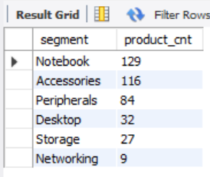

1. Follow-up: Which segment had the most increase in unique products in 2021 vs 2020? The final output contains these fields,

Segment

product_count_2020

product_count_2021

difference

WITH percentage_change as(

Select

d.segment,

count(distinct case when f.fiscal_year=2020 then d.product_code end) as product_count_2020,

count(distinct case when f.fiscal_year=2021 then d.product_code end) as product_count_2021

from fact_sales_monthly f

join dim_product d

on f.product_code=d.product_code

group by d.segment)

select *,

round((product_count_2021-product_count_2020)*100/product_count_2020,2) as prec_diff

from percentage_change

order by prec_diff desc;

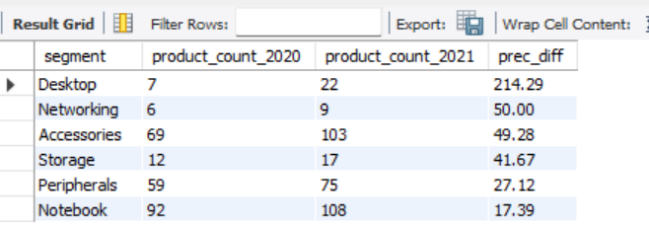

1. Get the products that have the highest and lowest manufacturing costs. The final output should contain these fields,

product_code

product

manufacturing_cost

SELECT

fm.product_code,product, manufacturing_cost

FROM fact_manufacturing_cost as fm

join dim_product as dm

on dm.product_code= fm.product_code

where manufacturing_cost=(select min(manufacturing_cost) from fact_manufacturing_cost)

or manufacturing_cost=(select max(manufacturing_cost) from fact_manufacturing_cost);

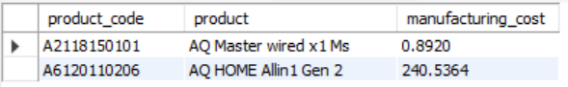

1. Generate a report which contains the top 5 customers who received an average high pre_invoice_discount_pct for the fiscal year 2021 and in the Indian market. The final output contains these fields,

customer_code

customer

average_discount_percentage.

SELECT

f.customer_code,

d.customer,

f.pre_invoice_discount_pct as average_discount_percentage

FROM

fact_pre_invoice_deductions AS f

JOIN

dim_customer AS d ON d.customer_code = f.customer_code

WHERE

f.fiscal_year = 2021

AND market = 'INdia'

AND f.pre_invoice_discount_pct > (SELECT

AVG(pre_invoice_discount_pct)

FROM fact_pre_invoice_deductions)

ORDER BY f.pre_invoice_discount_pct DESC

LIMIT 5;

